Global layout
HTML pages share a lot of common elements like the <head> tag and navigation menus. Instead of rendering these elements on every page, individually, we can create a global layout. We can then use the global layout as the base for all our pages. In this section, we will update our app config settings to accomodate this.
Heading back to cmd/main.go, we need to revisit our app’s config object. We will add a ViewsLayout property and set it to "layouts/main". This will apply the main layout to all our pages, by default.
1  2  3  4  5  6  7  8  9  10  11  12  13  14  15  16  17  18  19  20  21  22 | package main  import (  "github.com/divrhino/divrhino-trivia/database"  "github.com/gofiber/fiber/v2"  "github.com/gofiber/template/html"  )  func main() {  database.ConnectDb()  engine := html.New("./views", ".html")  app := fiber.New(fiber.Config{  Views: engine,  ViewsLayout: "layouts/main", // add this to config  })  setUpRoutes(app)  app.Listen(":3000")  }

This main layout file does not exist yet. So when we try to test this in the browser, we get this error:
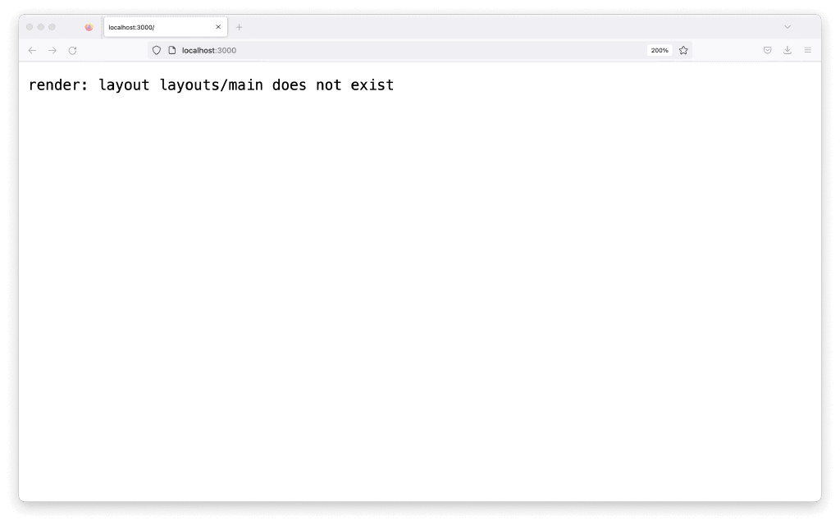
We can resolve the error by creating the main layout. Let’s first create a new folder for our layouts.
1 | mkdir views/layouts
Then we can create the main.html layout file here
1 | touch views/layouts/main.html
Opening up views/layouts/main.html, we’ll add the following content.
1  2  3  4  5  6  7  8  9  10  11  12  13  14 | <!DOCTYPE html>  <head>  <title>Div Rhino Trivia</title>  </head>  <body>  <div class="wrapper">  <h1>{{.Title}}</h1>  <h2>  {{.Subtitle}}  </h2>  {{embed}}  </div>  </body>  </html>
It’s just a basic HTML layout with a couple of headings. We’re rendering our .Title data within <h1> tags and our .Subtitle data within <h2> tags. Below these, we have an {{embed}}. The {{embed}} is where our individual page content will be rendered.
We have arbitrarily decided that all of our pages will have a {{.Title}} and {{.Subtitle}} field, so we can render them in the main layout, so that all our pages get the same layout. Of course, the contents of the fields will be different on each page because each page has its own context.
Remember that we already have a {{.Title}} and {{.Subtitle}} rendered in our index.html template. So if we check our browser now, we see double
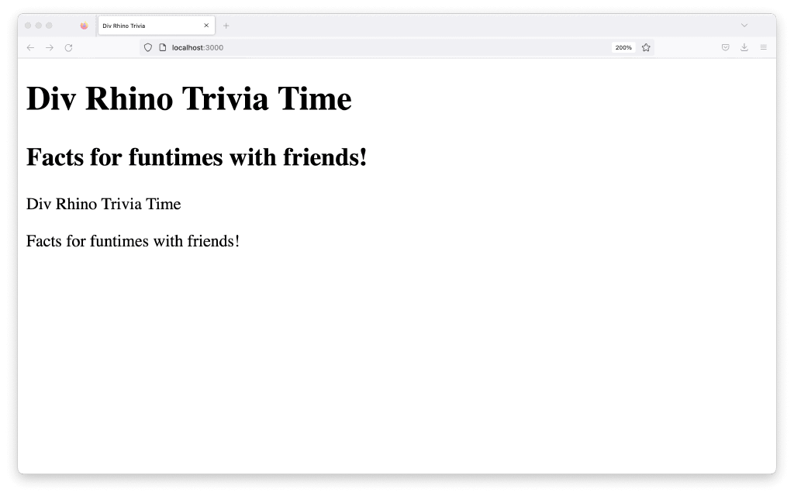
To fix this, we need to remove the fields from our index.html file and replace them with some temporary text:
1  2  3 | <!-- index.html -->  This content is unique to the index page
If we head into our browser now, we should see our main layout content has rendered along with the unique text we put in our index.html file.
